Background on CPI Card Group

Overview
CPI Card Group has accumulated more than 30 years’ experience in the market for payment card production and related services. CPI Card Group is a global leader in financial card production and related services under the VISA, MasterCard, American Express, Discover, and Interac payment brands. CPI Card Group serves financial institutions, group service providers, card processors, and prepaid debit card programs in the USA and internationally.

CPI Card Group provides a variety of consumer plastic cards including debit, credit, pre-paid, and identification cards. The company offers multiple types of contactless smart cards including Radio-frequency identification (RFID), RFID stickers, physical access cards, Frequency Operated Buttons (FOBs), Europay, MasterCard, and Visa (EMV) cards, and Micro Secure Digital (MicroSD) cards, for private and public organizations. CPI Card Group has expanded its business into gift card packaging with customization. The company can design and produce any type of custom gift card packaging. The company provides packaging customization such as daily processing for secure and non-secure card programs and Business-to-Business and Business-to-Customer card issuance, distribution, and smart card.

CPI Card Group has the largest secure production network in North America. CPI’s headquarters is in Colorado, USA. The Company has a secure facility in Canada to support daily issuance requirements as well as mass production. The company uses those facilities to support many different payment card programs, from one-to-one marketing to full-scale card deployment. The company also operates from multiple locations throughout the USA, Canada, and the U.K.

CPI Card Group provides solutions to a varied collection of more than 3,000 customers, both direct and indirect. CPI’s customers include large issuers of debit and credit cards, organizations providing prepaid debit cards, and independent community banks, credit unions, card processors, and group service providers.

Key Developments
Recent high profile security breaches have emphasized the need for the USA EMV market to expand and reach parity with other parts of the world. The EMV standard for smart payment cards, payment terminals, and automated teller machines was created by Europay, MasterCard, and Visa to improve security and transaction approvals. EMV cards store data on integrated circuits rather than magnetic stripes although magnetic stripes may still be used for backwards compatibility. EMV cards use a chip and PIN or chip and signature card for authentication. Readers for EMV cards can require physical contact or wireless usage via RFID technology.
Adoption of smart cards has lagged in the USA, but now most banks and financial institutions are moving to EMV-enabled cards. CPI is the largest smart card manufacturer in North America and one of the first to offer chip enabled credit cards in North America. CPI has been helping its customers to implement an EMV payment infrastructure to increase their business security. CPI’s production has been growing quickly as producing several million EMV cards in the last year and also working on pilot programs with major U.S. banks. The company has been expanding its network and partnership and became a trusted service manager for mobile payment applications. The recent partnership allowed the company to service and support the emerging mobile payments industry.
Acquisitions have been a major part of CPI’s growth with six acquisitions in the last decade. In 2014, CPI acquired EFT Source, a provider of personalization and fulfillment services for the financial payments industry. The acquisition extended CPI’s capacity and expertise as well as provided access to EFT Source’s customer base of small and medium financial card issuers.
CPI Card Group needs to generate funds for major new investments in information technology and production. Growth in the EMV market is crucial as profit potential is 2 to 3 times higher than for traditional magnetic stripe cards. CPI group is considering an Initial Public Offering (IPO) or another round of private equity funding. Record keeping requirements are stricter for an IPO, but the potential for funding is also much higher.

Workflow for Card Processing
As shown in Figure 1, CPI’s card processing begins with a lead generated for potential customers. Sales agents contact potential customers and generate a sales estimate for interested customers. Because each manufactured product has unique characteristics, every potential job requires an original estimate. The estimate covers material, labor, machines, and overhead used to build the end product. In most cases, the customer receives a quote letter with the estimate. Once agreed upon, the customer will issue a purchase order (PO) to the company for the job. At this point in time, a job is created within the ERP system and the estimate that was created outside the ERP system is merged to the job, joining all of the data needed to build the end product.
Once a job is entered by customer service, production planning will review the sales estimate needed to build the job. The job of production planning is to convert the sales estimate and data on the job into an actual manufacturing plan to produce the end product. During this process, customer proofs are also created. Once the proof has been approved, the production planning group schedules the job within an integrated planning system that shares information with the ERP system. At this time, the product runs through the manufacturing process. Throughout the manufacturing process production, data is entered into the ERP system to gather production statistics. Audits are also managed in the ERP system and carried out throughout the manufacturing process.
Once products in a job have been created and passed all quality and audit checks, the product is shipped to the customer. After shipping of the product, an invoice is generated and sent to the customer. For large jobs, multiple shipments and invoices may be necessary. Once the job has been shipped and invoiced, the company is able to recognize the revenue for all or part of the job that has been manufactured.
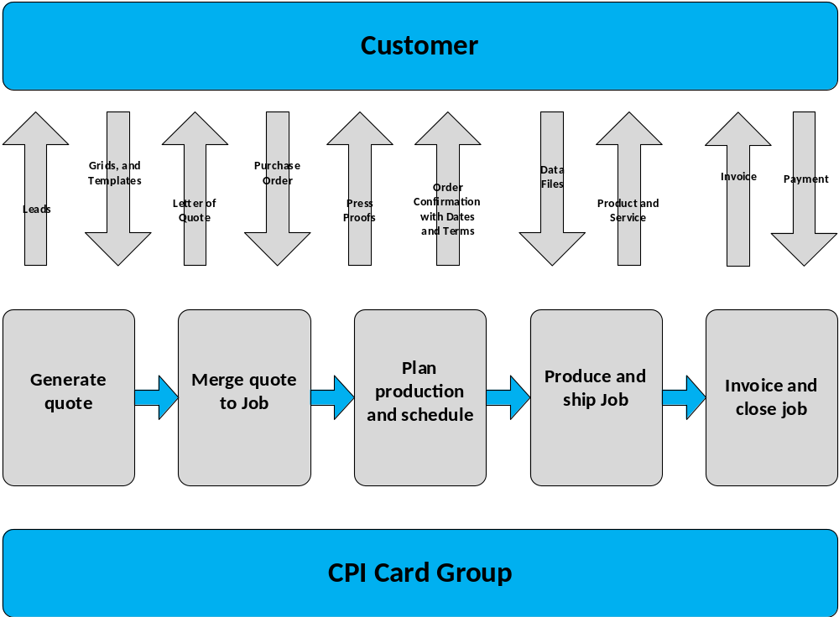Figure 1: Simplified Workflow Diagram for Card Processing

Business Intelligence Initiative
CPI Card Group has a new initiative for business intelligence with self-service reporting. CPI wants reporting to address higher level decision making for business intelligence, not just operational decisions. Self-service reporting is an approach that enables business users to access and work with the company’s data without information technology staff involvement. The biggest drivers for this initiative are:
- Turnaround time to the business for reports: The reports involve work by information technology staff because of the complex structure of the database. Backlog of requested reports exceed several months not allowing quick and accurate business decisions to be made.
- Development cost for dynamic reporting needs: Three full-time employees are dedicated to new report production. However, this staff is not adequate to support growth in reporting needs as the business expands especially with acquisitions.
- Lack of consolidated reporting across data sources: CPI Card Group needs reports that combine data sources used in systems for operations. Consolidated reporting combines data from customer relationship management, ERP for job production, and financial accounting.
- No self-service for end users for report generation: CPI Card Group wants to empower its business analysts with reporting tools. Business analysts can be trained to use reporting tools, but reporting tools will not be useful without a data warehouse. Business analysts want convenient dashboards containing visualizations and the ability to modify and create new reports.

This document and other case documents are based on the business situation at CPI Card Group with corporate headquarters in Littleton, CO, USA.

